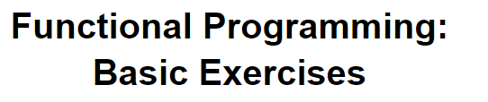

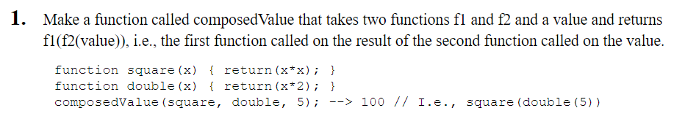

<html>

<body>

<script>

var n = prompt("Enter the value:");

//composedValue(square, double ,n);

function composedValue(f1,f2,n)

{

var value = f1(f2(n));

document.write(value);

}

function square(n)

{

return n\*n;

}

function double(n)

{

return n\*2;

}

</script>

</body>

</html>

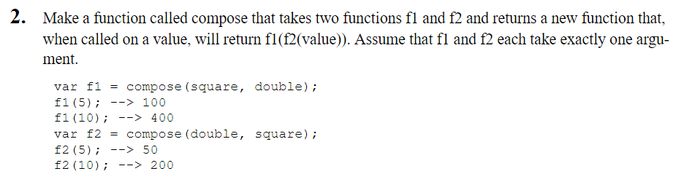

<html>

<body>

<script>

//compose(square,double,n);

function compose(f1,f2) {

function newfun(n){

return f1(f2(n));

}

var value = newfun(n);

document.write(value);

}

</script>

</body>

</html>

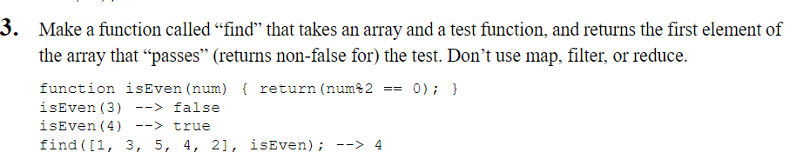

<html>

<body>

<script>

var a = [1,3,5,4,2];

find(a,test);

function find(a,test)

{

for(i=0;i<a.length; i++)

{

if(test(a[i]) == true)

{

document.write(a[i]);

break;

}

}

}

function test(n){

if( n%2==0)

return true;

else

return false;

}

</script>

</body>

</html>

<html>

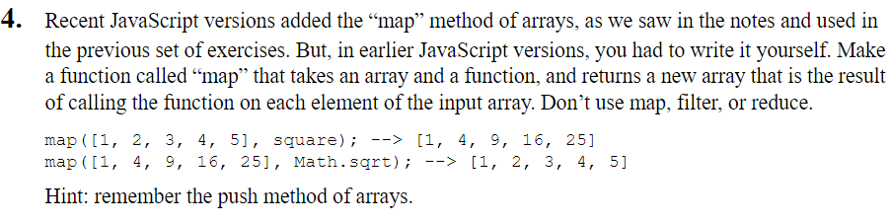

<html>

<body>

<script>

var a=[1,2,3,4,5];

function map(a,f1)

{

var b =[];

for(i=0;i<a.length;i++)

b.push(f1(a[i]));

document.write(b);

}

</script>

</body>

</html>

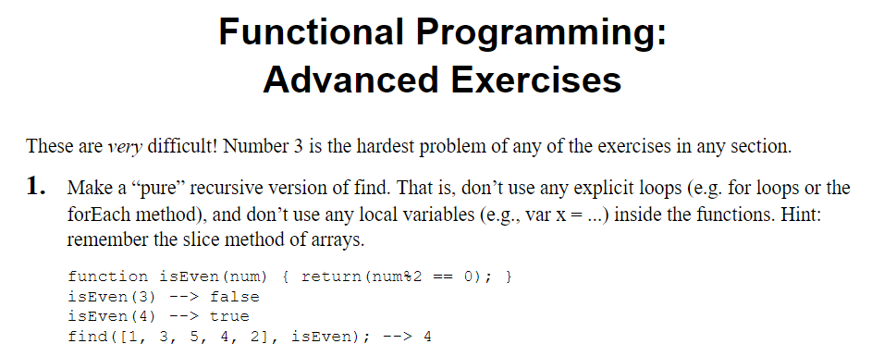

<html>

<body>

<script>

i=0;

var a=[1,2,3,4];

find(a,test);

function find()

{

if(test(a[i])== true)

{

document.write(a[i]);

}

else{

i++;

find();

}

}

function test(n){

if( n%2==0)

return true;

else

return false;

}

</script>

</body>

</html>

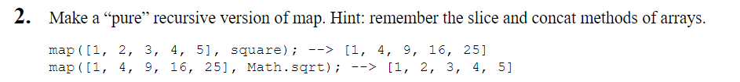

<!DOCTYPE html>

<html>

<body>

<script>

i=0;

var a=[1,2,3,4,5];

map(a,square);

console.log(map());

function map()

{

if(i < a.length)

{

document.write(square(a[i]) +"<br>");

i++;

map();

}else{

return;

}

}

function square(n)

{

return n\*n;

}

</script>

</body>

</html>